|  |  |
| --- | --- |
| 翻译前字数 | 399 |
| 目录 | Unity Manual/Unity Services/Unity Multiplayer |
| 链接 | https://docs.unity3d.com/540/Documentation/Manual/UnityMultiplayerService.html |

# Unity Multiplayer

# Unity 多玩家

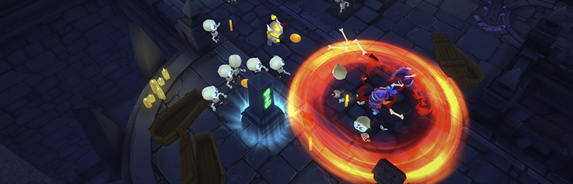

Unity Multiplayer is the easiest way to create real-time, networked games for Unity. It’s fast to implement and highly customizable. Unity-provided servers ensure that your players can find and play with each other.

Unity Multiplayer是在Unity中创建实时，联网游戏的最简便的方法。它可以快速实现并且高度定制。Unity提供的服务器确保您的玩家可以找到其他玩家。

**Note:** If you are upgrading your multiplayer project from an earlier version of Unity (before 5.4), there a number of changes to the API which you may need to update in your project. For more information, see the [5.4 networking upgrade guide](https://docs.unity3d.com/540/Documentation/Manual/UpgradeGuide54Networking.html).

注意：如果您升级了从5.4版本之前的多玩家项目，那么您可能需要在项目中更新一些API的变化。关于更多的信息，请参阅[5.4 网络升级指南](https://docs.unity3d.com/540/Documentation/Manual/UpgradeGuide54Networking.html)。

字数399